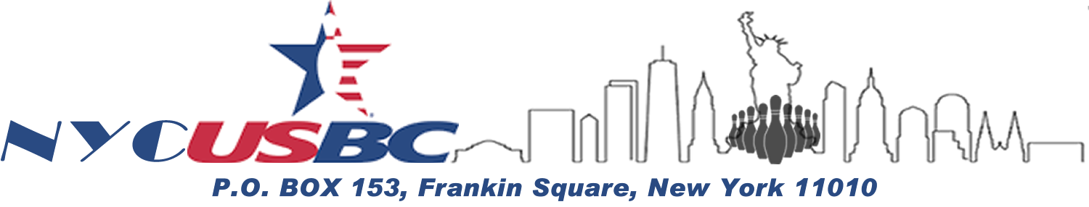

**Open & Women’s Tournament**



|  |  |  |  |  |  |  |  |
| --- | --- | --- | --- | --- | --- | --- | --- |
| **SINGLES, DOUBLES, & TEAM EVENTS – Squad Dates & Times** | | | | | | | |
| **Sat., June 3** | **Sun, June 4** | **Sat., June 10** | **Sun., June 11** | **Sat., June 17** | **Sun., June 18** | **Sat., June 24** | **Sun., June 25** |
| 10AM & 1PM | *No Squads* | 10AM & 1PM | 10AM & 1PM | 10AM & 1PM | 10AM & 1PM | 10AM, 1 & 4PM | 10AM & 1PM |

|  |
| --- |
| **Open to all NYCUSBC Members.** |
| **Entry Fee (per entry): Singles $50; Doubles $100; Team $200**  ***Pay at entry or send via Zelle: NYCUSBC@gmail.com*** |
| **1 in 8 Cash – USBC Sanctioned – Handicap 90% of 240** |

|  |  |  |  |  |  |  |  |  |
| --- | --- | --- | --- | --- | --- | --- | --- | --- |
| **Team Captain** | | | | | | | | |
| **Name** | | **Address** | | | | | | |
| **Team Information** | | | | **USBC Use: Entry Number _________** | | | | |
| **Bowler 1 Name** | | **USBC #** | | **Squad Date & Time** | | **Average** | | **ALL EVENTS 🞏** |
| **Bowler 2 Name** | | **USBC #** | | **Average** | | **ALL EVENTS 🞏** |
| **Bowler 3 Name** | | **USBC #** | | **Average** | | **ALL EVENTS 🞏** |
| **Bowler 4 Name** | | **USBC #** | | **Average** | | **ALL EVENTS 🞏** |
| **Doubles Information (Team 1)** | | | | **USBC Use: Entry Number _________** | | | | |
| **Bowler 1 Name** | | **USBC #** | | **Squad Date & Time** | | **Average** | | **ALL EVENTS 🞏** |
| **Bowler 2 Name** | | **USBC #** | | **Average** | | **ALL EVENTS 🞏** |
| **Doubles Information (Team 2)** | | | | **USBC Use: Entry Number _________** | | | | |
| **Bowler 1 Name** | | **USBC #** | | **Squad Date & Time** | | **Average** | | **ALL EVENTS 🞏** |
| **Bowler 2 Name** | | **USBC #** | | **Average** | | **ALL EVENTS 🞏** |
| **Singles Information** | | | | | | | | |
| **Name** | **USBC #** | | **Squad Date & Time** | | **Average** | | **USBC Entry #** | **ALL EVENTS 🞏** |
| **Name** | **USBC #** | | **Squad Date & Time** | | **Average** | | **USBC Entry #** | **ALL EVENTS 🞏** |
| **Name** | **USBC #** | | **Squad Date & Time** | | **Average** | | **USBC Entry #** | **ALL EVENTS 🞏** |
| **Name** | **USBC #** | | **Squad Date & Time** | | **Average** | | **USBC Entry #** | **ALL EVENTS 🞏** |