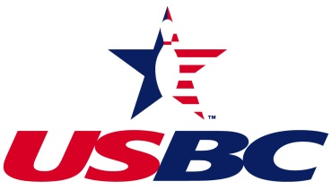

***New York City Association***

BOARD MEMBER & DELEGATE APPLICATION

**Name:**

**Address:**

**City, State, Zip Code:**

**Telephone: Home ( ) Cell ( )**

**Email Address:**

**Check Appropriate Position: ( ) Director**

**( ) USBC Delegate**

**( ) State Delegate (NY USBC)**

**Experience:**

**Current:**

**NYCUSBC Office or Position:**

**NYCUSBC Committees:**

**Previous:**

**NYCUSBC Office/Position: (include ABC, WIBC, YABA)**

**League Officer Positions Held:**

**Other Bowling Related Activities:**

**REQUIREMENTS:**

**Director Candidate:** To be nominated for the position of Director:

1. Candidate must be a member of this association in good standing and, if elected, maintain his/her membership through his/her term.
2. Candidate must be bondable by USBC and undergo and pass a USBC-approved background check through USBC’s approved vendor, if the candidate is 18 years of age or older.
3. Candidate must have basic knowledge of the “System of Bowling.”
4. Candidate must have good communication skills
5. Candidate must be able to commit time for association meetings, committee meetings, working tournaments, serving bowlers and presenting awards.
6. Candidate must be at least 18 years of age to be eligible to join the board as an adult director and at least 14 years of age to be eligible to join the board as a youth director. Candidates under 18, if elected, may not hold office, be in a position to sign contracts, or sign checks.
7. Candidate must be a RVP registered volunteer.

**USBC Delegate Candidate:**

1. Candidate must be at least 18 years of age.
2. If elected, a candidate must be a USBC member in good standing at the time of election and throughout his/her term.

**NY USBC Delegate Candidate:**

1. Candidate must be at least 14 years of age to be elected as a Youth Delegate.
2. Candidate must be at least 18 years of age to be elected as an Adult Delegate.
3. If elected, a candidate must be a USBC member in good standing at the time of election and throughout his/her term.

CANDIDATE SIGNATURE DATE

Submission Deadline: Thirty (30) days prior to Annual Meeting

Please note that candidates nominated from the floor must submit their application prior to the meeting to (fax and email copies will be accepted):

NEW YORK CITY USBC ASSOCIATION

PO Box 153

Franklin Square, NY 11010

Telephone (609) 433-4350

Email: nycusbc@gmail.com