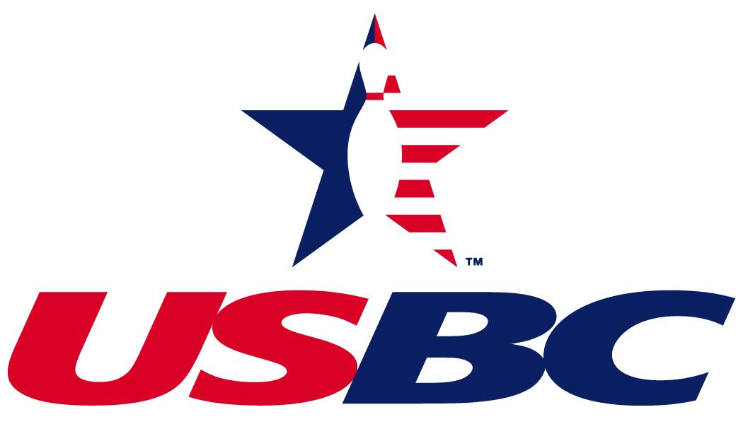

New York City Association

President's Report, July 11, 2021
To NYCUSBC members and friends:
The Board of Directors thanks you for giving us your confidence to lead this association through the difficult times we face in bowling. We continue to support the bowling centers and the league bowlers in the mission of growing the sport of bowling. During this 2021 Annual Meeting, we hope to show you what the current status is of the association and tell you of our plans moving forward. We will also inform you about the status of the state and national associations. It also gives you a chance to voice your opinions and vote on decisions that will make our association better.
I would like to thank the NYCUSBC Board of Directors, our Association Manager and our Administrative Assistant for another year of hard work. I would also like to give recognition to all of the league officers for their continued effort in making bowling in NYC the best it can be for our membership. Due to the COVID 19 virus, and at the suggestion of USBC, the 2019-2020 Annual Meeting of NYCUSBC was cancelled. Term limits had to be addressed. The Board, by electronic vote, approved extension of all Officer and Director terms for one year. Directors whose terms were to end July 31, 2020 were appointed to one year terms ending July 31, 2021.
I am here to report that our finances are all in order. Our budget and audit committee and our accountant have verified our accounts. NYCUSBC has made many cost cutting measures and will continue to cut the budget where we can in, order to service our membership. In 2014 we closed our Glendale Office and moved to a smaller location in Queens Village. In 2019 we closed the Queens Village office. The COVID Pandemic has hit New York City harder than the rest of our area. Bowlers stayed home instead of bowling and bowling establishments had to follow New York State guidelines and could not run at full occupancy.
NYC USBC anticipates being able to smoothly run our 2021 -2022 season and assist in the growth of all of our leagues. We are committed to try to increase our membership.
Today we will vote on a proposal and vote to elect Directors. We need your input, but whatever the outcome, NYCUSBC will continue to represent the bowlers of New York City
Please remember all of our deceased members who have died due to COVID 19 or died due to any other reason.
Paul A. Gilbert
President, NYCUSBC
pagilbert221@aol.com

