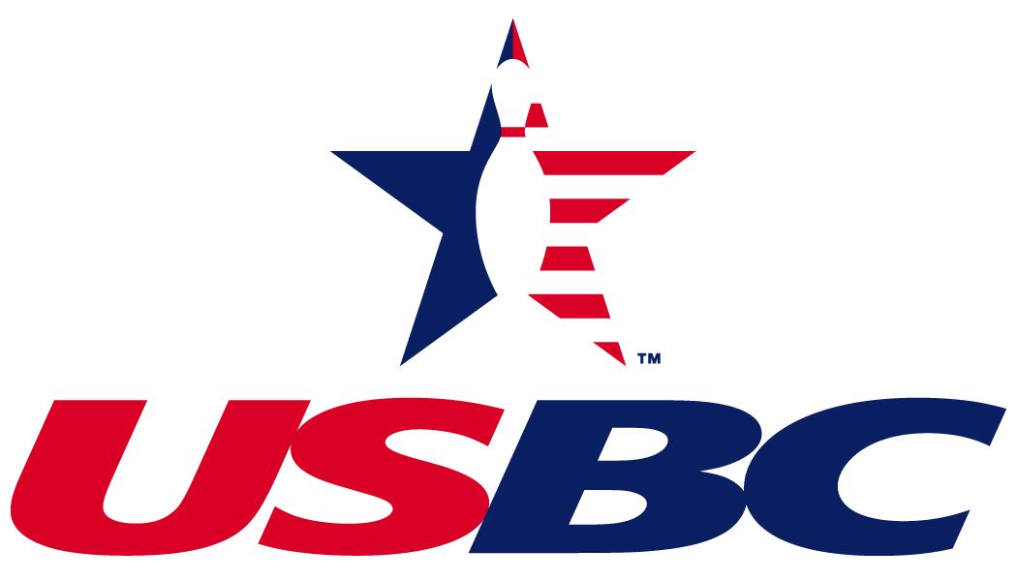

New York City Association

NYCUSBC Annual Meeting Agenda
Sunday, July 11, 2021

Handouts
Meeting Agenda
President’s Statement

Agenda
- Call to order

- Roll Call / Confirmation of Quorum Credentials / Minutes from 6/02/2019 Annual Meeting

- Association Statements
  - President’s report
  - Association Manager Report & Financial report

- Committee Reports
  - Budget/Finance Committee
  - Youth Committee
  - Special Awards Committee
  - National & State Convention Report

- Special Orders
  - Nominating Committee Report / Credentials
  - Voting for Board Members
  - By-laws Amendment

- Question and Answers

- President’s Closing/ Motion to Adjourn

Paul A. Gilbert
NYCUSBC President
pagilbert221@aol.com

