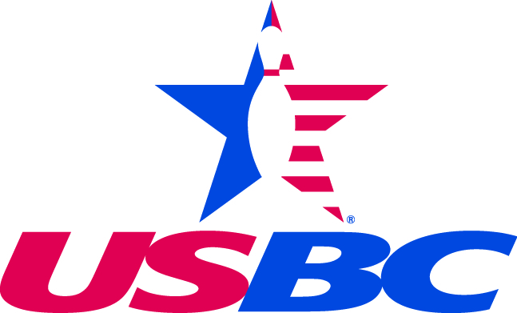
New York City Association

Amendment No. B 1
NYC USBC Local Bylaws
Article IV, Membership and Dues
Allows NYC USBC dues to increase of $ 5.
ARTICLE IV – Membership and Dues

The annual adult standard membership dues are as follows:
Local $ 10.00.
State $ 1.00 (Cannot exceed $5.)
USBC adult standard membership $ 13.00
Total $ 24.00.

Change By-Law to read

The annual adult standard membership dues are as follows:
Local $ 15.00.
State $ 1.00 (Cannot exceed $5.)
USBC adult standard membership $ 13.00
Total $ 29.00.

This is necessary to meet financial responsibility to conduct association business.

USBC Membership has drastically decreased over the past decade. NYCUSBC has not raised its portion of the dues in that time and we have survived off of the previous surplus. Using cost saving measures, NYCUSBC moved from our office in Glendale to a smaller office in Queens Village. Last year we closed that office and now have our staff working from home.

During the Corona Virus global pandemic we have lost a huge part of our association membership. We do expect a significant number of bowlers to return in the summer and fall seasons. The Association was assisted by a PPP loan to keep our employees on payroll. Now that the fall season is over we intend to close the office and furlough staff for a month to further cut cost.

All of these reasons led us to decide to propose to raise membership dues by $5. By doing so, we'll be able to continue to supply the value support that NYC USBC offers,

