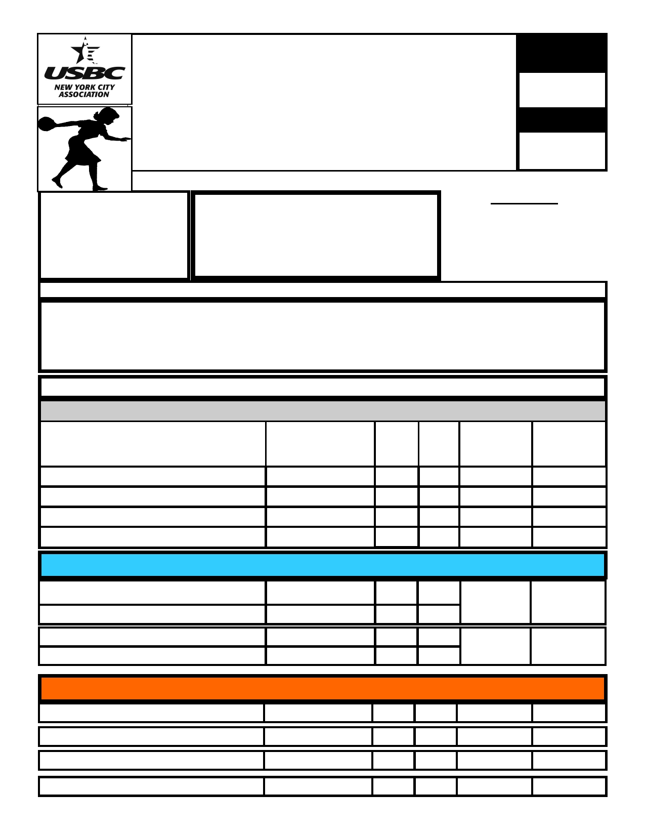

USBC
93rd Annual New York City USBC
Entry Number

Certified
Women's Championships

Money Collected
June 10, 11, 17, 18, 24, 25- 2017

Open only to New York City USBC members
ATTENTION:
JIB Lanes All bowlers must have

Separate Singles Event

Separate Doubles Event
67-19 Parsons Blvd Flushing, NY 11365
(718) 591-0600
a USBC card or associate card
issued through the
New York City USBC Association

Read Rules on back of application

APPLICATION MUST BE FILLED OUT COMPLETELY OR IT WILL NOT BE ACCEPTED

Captains Information: Name:____________________________________________________ Address:______________________________________________________________________

Bowler Information
Team Name: Date and Time:
2015- 2016- Team
First Name - Last Name USBC I D # 2016 2017 Handicap All Events
Avg Avg $120 $10.00

Doubles only:

Singles only:

Date and Time:

Date and Time:

Handicap

$60

Handicap
$60

Handicap:$30

Handicap:$30

Handicap:$30

Handicap:$30

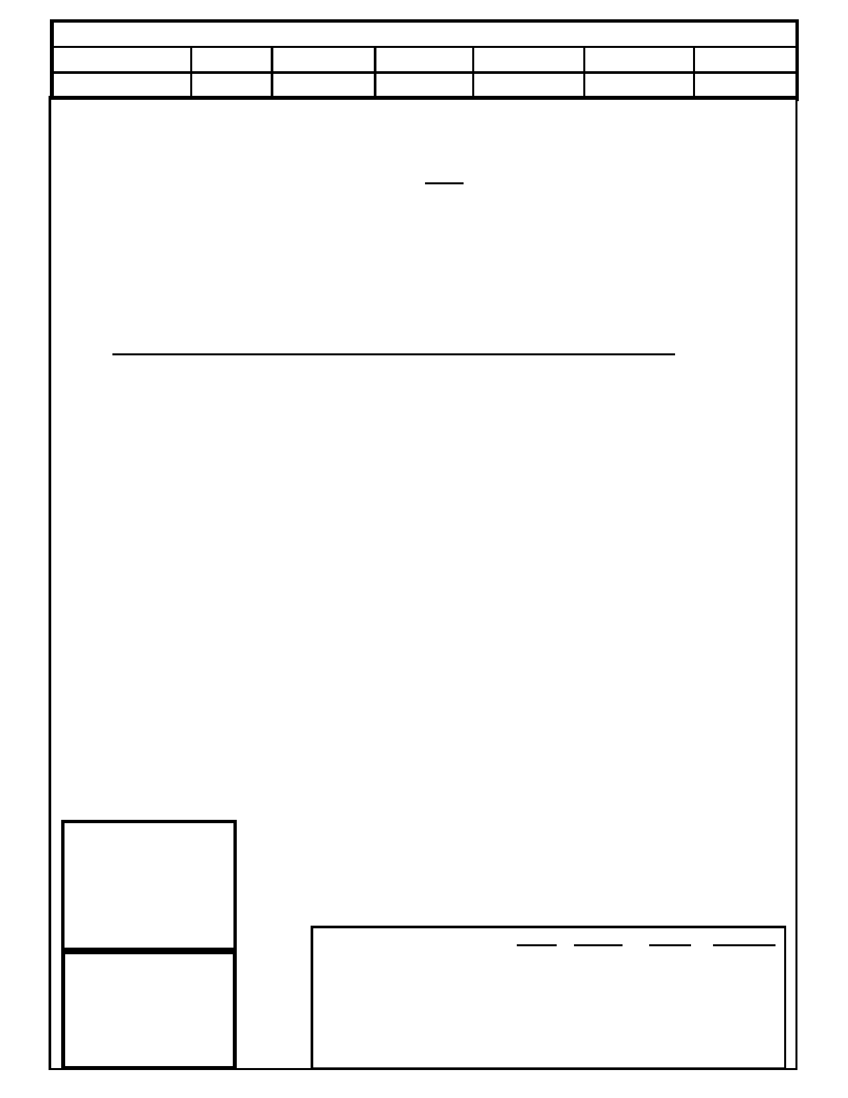Dates: : June 10, 11, 17, 18, 24, 25- 2017
Team Event 10:00 AM 100 PM 4:00 PM
Doubles or Singles 10:00 AM 12:00 PM 2:00 PM 4:00 PM 6:00 PM

1)
2)
3)

4)

5)

6)

7)
8)

9)

10)
11)

12)

13)

14)

15)
16)

17)

18)

All entries to this tournament must be made in accordance with USBC Tournament Rules.
This tournament is open to NYCUSBC Certified bowlers only.
Handicap. Handicap will be based on 90% of the difference between the bowler's or teams entering average and the following figures: 4-
Person Event - 960, 2-Person Event - 480, Individual Event - 240. All handicaps will be computed on a three game basis. All bowlers will
bowl the handicap division.
The average for entry into this tournament shall be the bowler's highest USBC sanctioned average between the 2015-2016 season or
the 2016-2017 season, based on at least 21 games ( 2016 summer averages included), which ever is higher with the following excep-
tions:
A. Only NYCUSBC jurisdictional averages will be used.
B. Individuals who have no NYCUSBC certified average for at least 21 games for the 2016-2017 season will use their highest
NYCUSBC certified average for the 2015-2016season (providing it is at least 21 games) and vice versa.
C. If a bowler has a NYCUSBC Sport Bowling average, it will be adjusted (See Chart on Page 77 of USBC Rule Book) to comply with
Rule 5B.
D. Individuals who have no NYCUSBC certified average for at least 21 games for either the 2015-2016 or 2016-2017 seasons will enter
with an average of 240.
E. All averages will be verified and corrected by NYCUSBC prior to issuing prize checks.
Team Captains and members must present USBC membership cards at the registration desk. Teams or individuals failing to appear on the lanes when scheduled to bowl shall forfeit their entry unless sufficient reason is given to Tournament Management to warrant postpone-
ment. Teams may not bowl singles or doubles in the squad directly following in an effort to keep squads on time
Any person who bowls under an assumed name or any team that knowingly accepts a person who assumed the name of another individual
shall both individually and collectively forfeit their entry fees and all prize money, and all persons connected with this affair shall be subjected
to suspension from USBC membership.
USBC Rules 319D & 319E will be in effect .
Any bowler who has at any time, been re-rated by any tournament, association or league, must inform the Tournament Management of such re -rate in writing before bowling in this tournament.
Four person teams may re-enter as often as they wish, but must change two bowlers to cash more than once if qualified. Singles and Doubles
events are not linked. There will be a maximum of 3 doubles/singles teams on each pair. Bowlers do not have to bowl both singles and dou- bles. You may only cash once with the same partner in doubles and only once in the singles.
Entries accepted up to 30 minutes prior to scheduled squad time or at the discretion of the tournament officials if lanes are available.
Any error on any score sheet must be reported in writing to the Tournament Management within 48 hours after completion of squad during which error was recorded.
There will be an Optional All-Events competition for which a fee of $10.00 will be charged. Entry fee must be paid prior to first ball
thrown in the tournament. Prize fee will be returned 100% in All-Events prizes. Scores will be computed using 90% handicap and actual
score for the first three games in each of the three events in the tournament. 1 in 10 cash (per division) No scratch prizes.
In addition to cash prizes, jackets and USBC Local Association Championship chevrons will be awarded to the first place finishers. All
awards will be given out at the NYCUSBC Awards Luncheon/Dinner - Winners will receive one free ticket. Additional tickets can be pur-
chased.
No refunds will be issued on a claim of not having received confirmation of squad time. It is the responsibility of each team captain to call the NYCUSBC office on the Thursday before their earliest squad choice, if confirmation has not been received.
One cash prize will be awarded for each 8 entries in each event, except the optional All-events. (Rule 13)
Premature termination of the tournament brought about by war, natural disaster, fire, or any other cause beyond the control of the New York City USBC Association shall cause all advertised prizes, guaranteed or otherwise, to be prorated in accordance with the number of entrants
who have bowled in each of the respective events up to the time of termination. Bowlers whose scheduled participation in this tournament is
cancelled due to such premature termination shall receive full refund of entry fees paid for participation so canceled.
The Tournament Management, if he/she sees fit, can add additional squads to the tournament, but at no time will the additional
squads be after June 25, 2017 at 4:00 PM. Walk-in entries are permitted, Re-entries will be permitted if lanes are available and those entries close June 25, 2017 at 5:00 PM. This tournament will run concurrent with the Open Championships and lanes will be limited.
NO REFUNDS

Each Event is

Make Checks Payable to:
NYCUSBC
& mail to:
NYCUSBC
102-38 221 Street
Queens Village, New York
11429
$30 per bowler
for
Team, Singles and Doubles

718-366-6922

Separate Singles
Event
Separate Doubles
Event
Handicap Events ONLY
Prize Fee (100% Returned)
Tournament Expenses
Lineage
Total Entry Fees
4-Man
$ 64.00 $ 20.00 $ 36.00
$120.00
Doubles
$ 32.00
$10.00
$ 18.00
$60.00
($30 each)
Singles
$16.00 $ 5.00 $ 9.00
$30.00
All-Events
$ 9.50 $ .50

$ 10.00

bowler)

