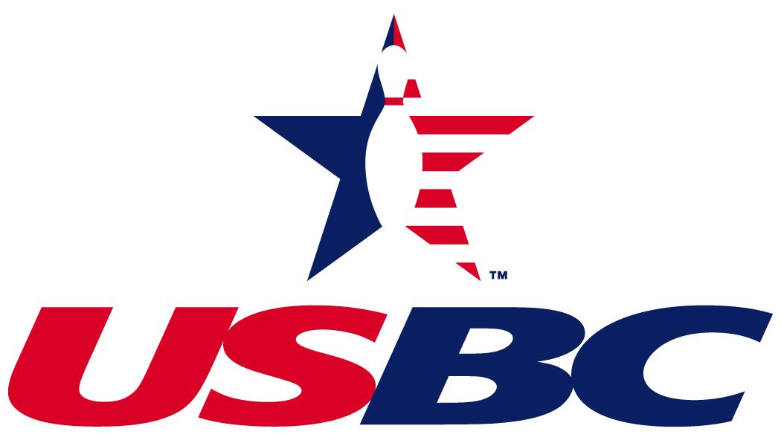

New York City Association
NYC USBC Association
102-38 221 Street
Queens Village, NY 11429

ANNUAL MEETING 2016

June 5, 2016
Jib lanes
67-19 Parsons Blvd
Flushing, NY 11365
2:00 PM – 5:00 PM

Please inform other members of your league of their right to attend

NYCUSBC is YOUR association!! Let your voice be heard
Bring your current USBC membership card for identification

- Election of Eligible Officers and Directors
- Delegates to National and State Conventions in 2017
- What’s Going on with NYCUSBC, USBC

If you are interested in being a member of he Board of Directors, please send in a resume by May 20, 2016

Mail to: Jacquie Yarborough, Chairperson
c/0 NYCUSBC
102-38 221 Street
Queens Village, NY 11429

