

**NYC USBC'S YOUTH CHAMPIONSHIP**

**SCHOLARSHIP TOURNAMENT**

**Singles & Doubles**

SINGLES

Name_____________________________ USBC Bowler ID____________2014-2015 USBC Book AVG______DOB___/___/____

Address____________________________________________________Email Address___________________________

Parent Email_____________________________Tel #___________________________

DOUBLES

BOWLER # 1

Name_____________________________USBC Bowler ID____________2014-2015 USBC Book AVG______ DOB___/___/____

Address____________________________________________________ Email Address___________________________________

Parent Email_____________________________ Tel #_________________________

BOWLER # 2

Name_____________________________ USBC Bowler ID________2014-2015 USBC Book AVG______ DOB___/___/____

Address_____________________________________________________Email Address__________________________________

Parent Email_____________________________ Tel #________________________

PRE REGISTER BY EMAILING YOUR YOUTH DIRECTORS

Yvette Walker -- **Bklyncablelady@aol.com**

Patrice Gilbert -- [Prekew2@aol.com](mailto:PREKEW2@aol.com)

1st and 2nd place are guaranteed a scholarship prize. 3rd is based upon entries

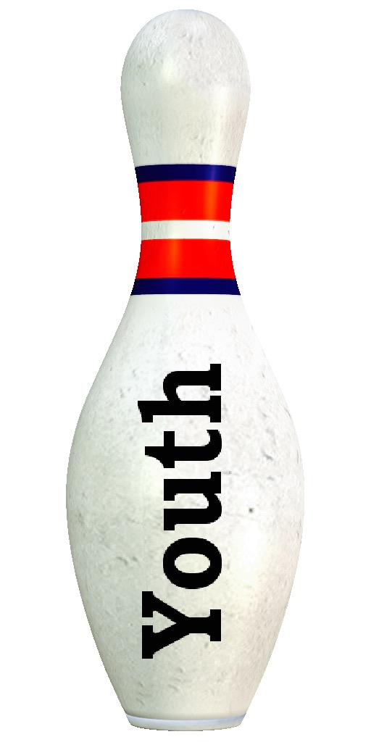

Select Squads

12PM 3PM

SINGLES Singles.

Doubles DOUBLES

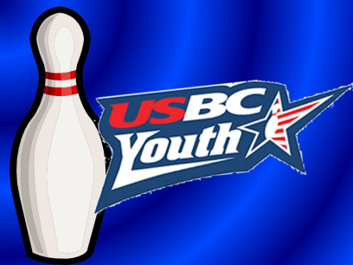

APRIL 2nd

2016

**Must have a USBC youth membership card for the 2015-2016 season.**

**STRIKE 10 LANES**

**6161 Strickland Ave Brooklyn, NY 11234**

**$25.00 ENTRY FEE**

NYC USBC USE ONLY

ENTRY NUMBER________

________

AMOUNT__________



NYC Usbc youth championship tournament rules

1) All entries to this tournament must be made in accordance with USBC Tournament Rules.

2) All participants must be youth members of a USBC Association. Handicap will be based on 90% of the difference between the bowler’s average and 200 (HDCP based on 200). All handicaps will be computed on a three game basis.

3) The average for entry into this tournament shall be the bowler’s highest current USBC average for the 2015/2016 season, based on at least 21 games. Coaches will have to furnish current average sheets.

4) All averages will be verified and corrected by the NYCUSBC office prior to issuing Scholarships.

5) All Individuals failing to appear on the lanes when scheduled to bowl shall forfeit their entry unless sufficient reason is given to Tournament Management to warrant postponement.

6) Any person who bowls under an assumed name of another individual shall forfeit their entry fees and all prize money, and all persons connected with this affair shall be subjected to suspension from USBC membership.

7) USBC Rules 319D & 319E will be not be effect .

8) An individual may re-enter as often as they wish, There will be a maximum of 6 bowlers on each pair. All bowlers must bowl singles You may only win one scholarship once in the singles. All scholarship prizes will be award based on entries.

9) Entries accepted up to 15 minutes prior to scheduled squad time or at the discretion of tournament officials.

10) Any error on any score sheet must be reported in writing to the Tournament Management within 48 hours after completion of squad during which error was recorded.

11) No refunds will be issued on a claim of not having received confirmation of squad time. It is the responsibility of each team captain to call the NYCUSBC office on the Thursday before their earliest squad choice, if confirmation has not been received.

12) USBC Local Association Championship chevrons certificates and scholarship will be awarded to the first place finishers of each division. These awards will be given out at the NYCUSBC Awards Luncheon/dinner—Winners will receive one free paid ticket. Additional tickets will be available for purchase.

13) Premature termination of the tournament brought about by war, natural disaster, fire, or any other cause beyond the control of the New York City USBC Association shall cause all advertised prizes, guaranteed or otherwise, to be prorated in accordance with the number of entrants who have bowled in each of the respective events up to the time of termination. Bowlers whose scheduled participation in this tournament is cancelled due to such premature termination shall receive full refund of entry fees paid for participation so canceled.

14) NO REFUNDS - There will be an additional $5 walk-in charge per event.

FEE BREAKDOWN

SINGLES

PRIZE FEE $12.25

LINEAGE $9.75

TOURNAMENT FEE $3.00

**$25.00**

Make Check Payable to:

New York City USBC

P O Box 280746

Queens Village, New York 11428

DOUBLES

PRIZE FEE $24.50

LINEAGE $19.50

TOURNAMENT EXPENE $6.00

**$25.00**

**Make Check Payable to:**

**New York City USBC**

**P O Box 280746**

**Queens Village, New York 11428**